GameBase Application Project Proposal

Table of Contents

Introduction and Requirements 1

Functional Requirements 1

Non-Functional Requirements 2

Working Hypotheses 2

Specification 3

Actors and Use Cases Diagram 3

Software Architecture 5

Analysis Classes Diagram 7

Classes Definitions 8

Classes Attributes 8

Graphical User Interface Mock-ups 11

Introduction and Requirements

The application project proposed in this paper consists in a software solution (preliminarily named “*GameBase”*) whose core functionality is collecting, organizing, and offering information related to videogames, allowing its users to search and browse for games using different filters (e.g. title, release date, platform, etc…) and view detailed information on such games.  
In order to enhance the application user experience, users will be allowed some limited interaction, on the one side regarding the games, such as adding a title to their *favourites* and view their favourite games list, and on the other concerning other users, such as the possibility to *follow* another user and view his favourite games list.  
In addition, in order for the application to produce an income (or at least, to ensure self-sustainability) on the one hand users will be offered a one-time payment option allowing them to perform more advanced queries on the dataset whose results will be presented as statistics, a solution which should appeal to professional-oriented users such as data analysts, and on the other the games should present, when applicable, links to affiliated digital stores allowing users to purchase them.

Functional Requirements

The following list summarizes the projected functional requirements of the application:

* The videogames dataset should be conspicuous in size, and should be composed of data of different nature, such as text, images, video, hyperlinks to related content, etc… (hypermedia).
* Access to the application is to be granted to registered users only through a login system based on the *username/password* model, in order to also distinguish the different user categories in the application (standard users, analysts and administrators) with their related privileges.  
  A sign-up form allowing new users to register within the application as standard users must also be provided.
* The following functions must be offered to the application’s administrators:
* Update the entire games dataset or the information relative to a single game (where a dynamic scraping mechanism will be considered).
* Delete a game from the dataset.
* Delete a user from the application.
* The following functions must be offered to the application’s standard users:
* Search and browse the list of games using different filters, such as title, release date, platform, genre, etc…
* View the detailed information relative to a game.
* Add/remove a game from their favourites list.
* Follow/unfollow another user.
* View the favourite games list of followed users.
* Perform a one-time payment to upgrade their account to an analyst account.
* Enter and update their personal information, including name, gender, age, favourite game genre, etc…
* Follow links to affiliated digital stores in order to purchase games.
* The analysts must be allowed to perform a set of advanced queries on the games’ and users’ datasets, whose results must be presented in the form of statistics.

Non-Functional Requirements

As for the non-functional requirements, given that the success and profitability of the application strictly relies on the number of active users, a modern structured graphical interface must be provided in order to enhance the user experience with the application.

In addition, since a professional-grade quality of service (QoS) is desired, both in terms of responsiveness and tolerance to single points of failure, the dataset of the application should be replicated and possibly sharded among different servers, a solution that allows for load-balancing purposes and future-proofs a possible development towards a content distribution network (CDN) architecture.

Working Hypotheses

The design of the application will also rely on the following working hypotheses:

* The details of how the payment relative to a user upgrading their account to an analyst account is processed are not taken into consideration.
* Existing regulations and concerns relative to the users’ data privacy are not taken into account.
* Advanced aspects relative to data replication, such as load balancing and disaster recovery, are not taken into account.

Specification

Actors and Use Cases Diagram

From the software functional requirements, the application is meant to be used by four actors:

* The Anonymous Users, who are allowed only to log in or register within the application, in the latter case possibly providing additional personal details.
* The Standard Users, who are allowed to interact with most of the application’s featuressuch as browsing, finding and viewing the detailed information regarding games, add a game to their favourites list, follow other users, see the followed users’ favourites lists, perform a one-time payment to upgrade their account to an analyst account, update their personal account information, and follow affiliated links to digital stores in order to purchase games
* The Analysts, who in addition to the features offered to the standard users are also allowed to perform a set of advanced queries on the games’ and users’ datasets, whose results will be presented as statistics.
* The Administrators, who are allowed to perform every operation in the application, including the ones requiring a high level of privilege such as updating the entire games dataset or the information relative to a single game, and delete a user or a game from the application.

The set of actors with their use cases is shown in the diagram below:

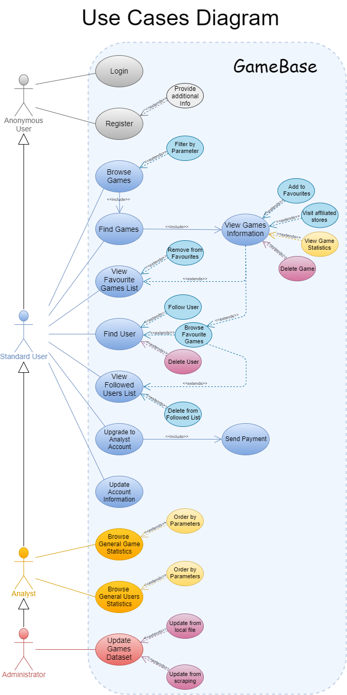

Software Architecture

As for its architecture, the software will be divided into three tiers according to the *Front-End – Middleware – Back-End* paradigm, where *Java* 8 will be used as the core programming language:

Front-End

The Front-End will consist in a graphical interface developed through the *WindowBuilder* API to allow users to interact with the application, along with the modules required to exchange data with the Middleware.

Middleware

The Middleware will comprise the logic and the data routing aspects of the application, where:

* The *Games* dataset will be managed using the *MongoDB* 4.4.2 document database and will be partitioned into two separate replicated shards, where the middleware will host a *mongos* instance acting as a router between the application logic and the shards and a *mongod* instance acting as configuration server for the latter.
* The *Users* dataset will be managed using the *Neo4j* 3.5 graph database, where the possibility of deploying replica servers based on the casual clustering model will be taken into consideration.

Back-End

The Back-End will comprise the data persistence aspects of the application where, as discussed above:

* The *Games* dataset will be partitioned into two *MongoDB* shards, each consisting of a replica set composed of 3 *mongod* instances (1 primary and 2 secondary).
* The *Users* dataset will be stored in a *Neo4j* instance, where the possibility of deploying replica servers based on the casual clustering model will be taken into consideration.

The following diagram summarizes the overall software architecture of our application:

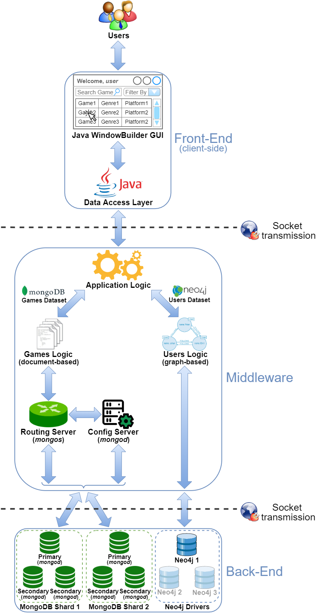

Analysis Classes Diagram

From the software’s requirements and the additional working hypotheses the following analysis classes can be identified within the application:

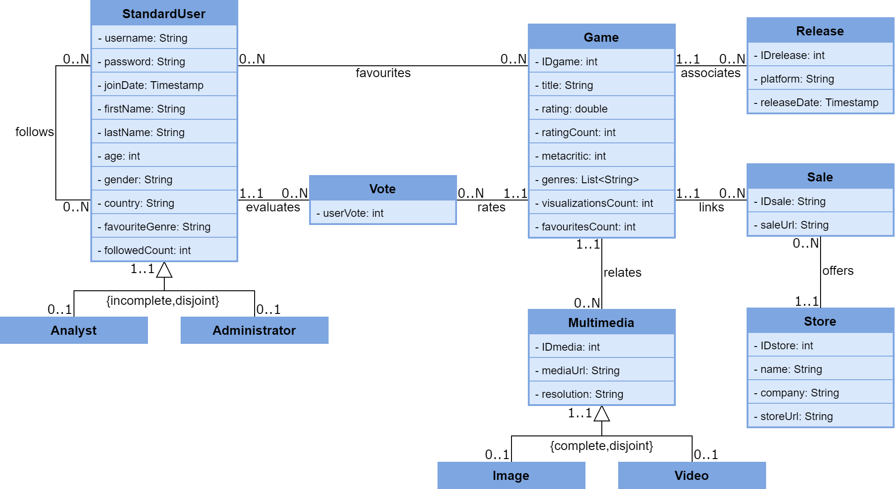

Classes Definitions

|  |  |
| --- | --- |
| CLASS | DESCRIPTION |
| StandardUser | A user with no special privileges within the application, who is nevertheless allowed to interact with most of its functionalities |
| Analyst | A special user who is allowed to perform advanced queries on the users’ and games’ datasets, whose results will be presented as statistics |
| Administrator | A super user who is allowed to perform every operation in the application |
| Game | A videogame whose information is offered by the application |
| Vote | A user’s evaluation of a game |
| Release | A release of a particular game for a specific platform |
| Multimedia | A multimedia content related to a particular game, which may consist in an image or a video clip |
| Image | An image related to a particular game |
| Video | A video clip related to a particular game |
| Store | An affiliated digital store where users can purchase games |
| Sale | A sale offer of a particular game in a specific store |

Classes Attributes

|  |  |  |
| --- | --- | --- |
| StandardUser | | |
| **Attribute** | **Type** | **Description** |
| username | String | A unique string identifying the user, which is also used by them to access the application |
| password | String | The password required for the user to access the application |
| joinDate | Timestamp | The date and time the user registered within the application |
| firstName | String | The user’s first name (optional) |
| lastName | String | The user’s last name (optional) |
| age | int | The user’s age (optional) |
| gender | String | The user’s gender (optional) |
| country | String | The user’s country (optional) |
| favouriteGenre | String | The user’s favourite videogame genre (optional) |
| followedCount | int | The number of the user’s followers |

|  |  |  |
| --- | --- | --- |
| Analyst | | |
| **Attribute** | **Type** | **Description** |
| none (same as the superclass) | | |

|  |  |  |
| --- | --- | --- |
| Administrator | | |
| **Attribute** | **Type** | **Description** |
| none (same as the superclass) | | |

|  |  |  |
| --- | --- | --- |
| Game | | |
| **Attribute** | **Type** | **Description** |
| IDgame | int | The game’s unique identifier |
| title | String | The game’s title |
| rating | double | The mean of all users’ evaluations of the game, expressed as a decimal number between 1.0 and 5.0 |
| ratingCount | int | The number of unique users’ evaluations of the game |
| metacritic | int | The Metacritic® rating of the game |
| genres | List<String> | The list of genres the game belongs to |
| visualizationsCount | int | The number of times the game was viewed by a user |
| favouritesCount | int | The number of users who have added the game to their favourites list |

|  |  |  |
| --- | --- | --- |
| Vote | | |
| **Attribute** | **Type** | **Description** |
| userVote | int | A user’s evaluation of a specific game expressed as an integer between 1 and 5 |

|  |  |  |
| --- | --- | --- |
| Release | | |
| **Attribute** | **Type** | **Description** |
| IDrelease | int | The game release’s unique identifier |
| platform | String | The platform on which the game was released |
| releaseDate | Timestamp | The release date of the game for the platform |

|  |  |  |
| --- | --- | --- |
| Multimedia | | |
| **Attribute** | **Type** | **Description** |
| IDmedia | int | The multimedia content’s unique identifier |
| mediaUrl | String | The URL from which the multimedia content can be retrieved |
| resolution | String | The multimedia content’s resolution (e.g. 1920x1080) |

|  |  |  |
| --- | --- | --- |
| Image | | |
| **Attribute** | **Type** | **Description** |
| none (same as the superclass) | | |

|  |  |  |
| --- | --- | --- |
| Video | | |
| **Attribute** | **Type** | **Description** |
| none (same as the superclass) | | |

|  |  |  |
| --- | --- | --- |
| Store | | |
| **Attribute** | **Type** | **Description** |
| IDstore | int | The store’s unique identifier |
| name | String | The store’s name |
| company | String | The store’s owner company |
| storeUrl | Timestamp | The URL of the store’s homepage |

|  |  |  |
| --- | --- | --- |
| Sale | | |
| **Attribute** | **Type** | **Description** |
| IDsale | int | The sale’s unique identifier |
| saleUrl | String | The game’s URL within the store |

Graphical User Interface Mock-ups

As the last part of this application proposal, we present some mock-ups of the graphical user interface:

Login Screen

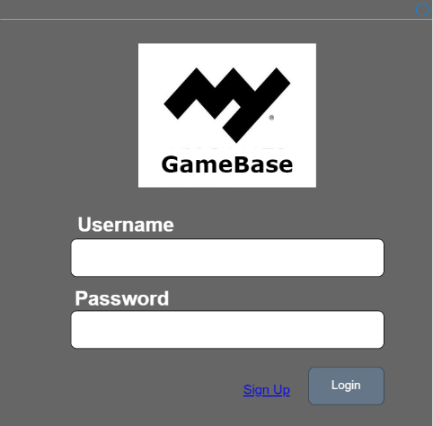

Main Window

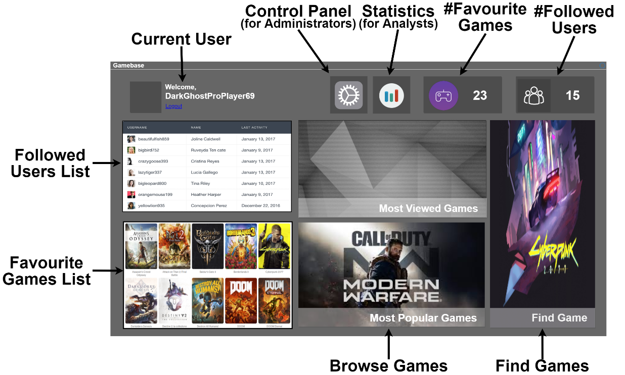

Browse/Search Game Window

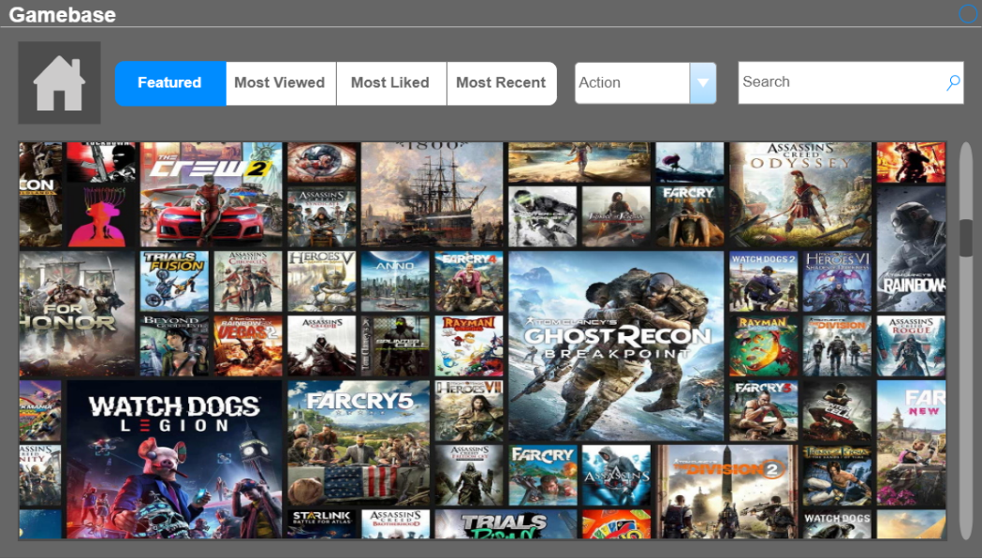

Game View

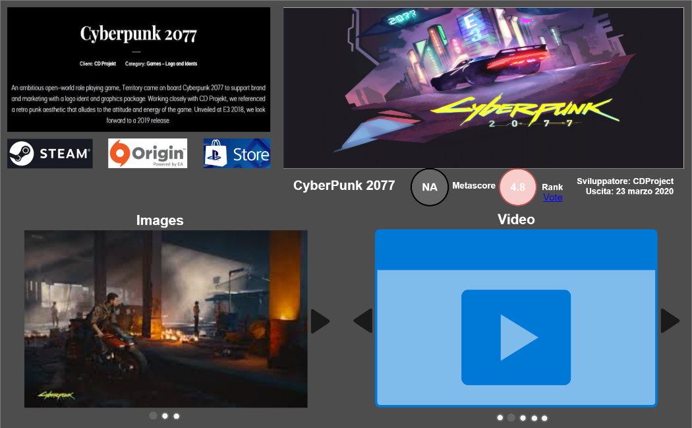

Statistics Page

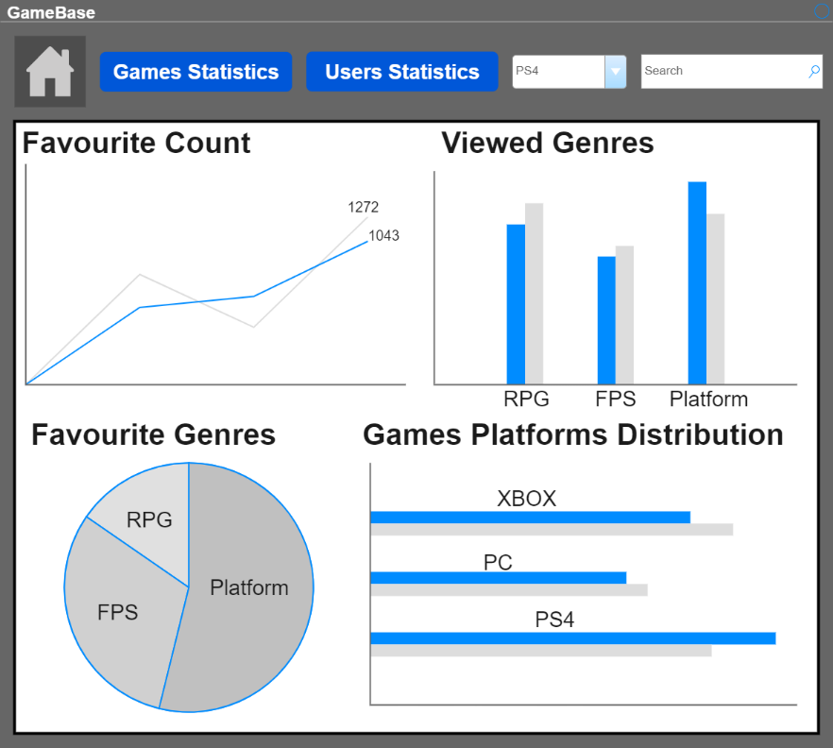

Administration Panel

